PCB Defect Detection – Visual Results Documentation

1.MODEL A :

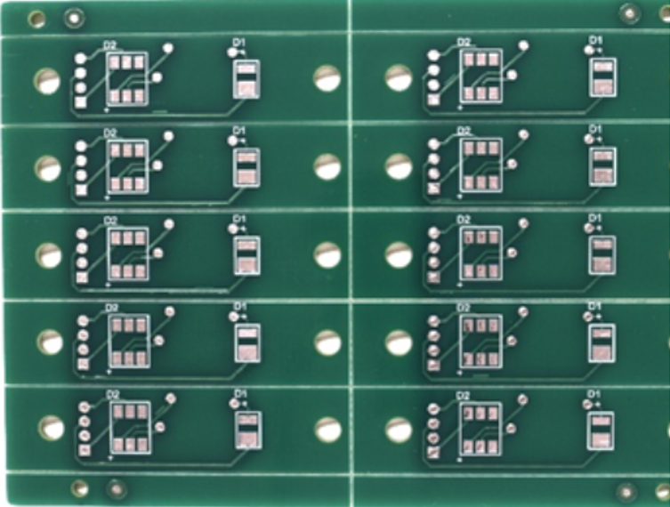 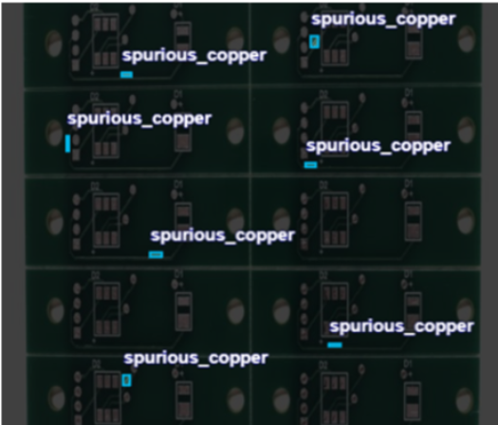 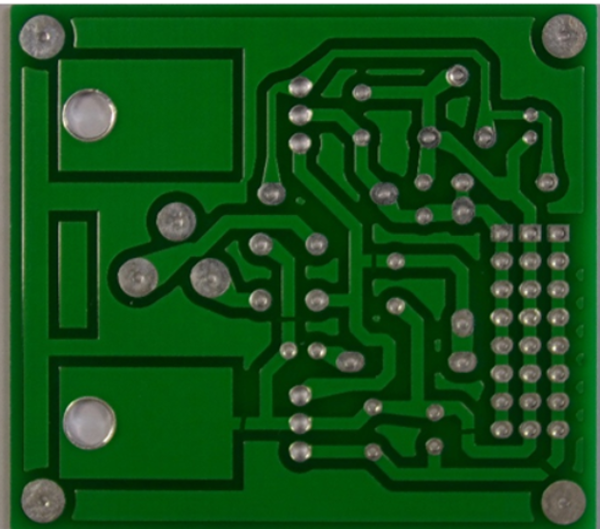 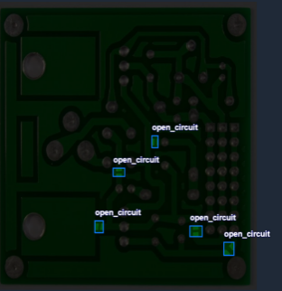

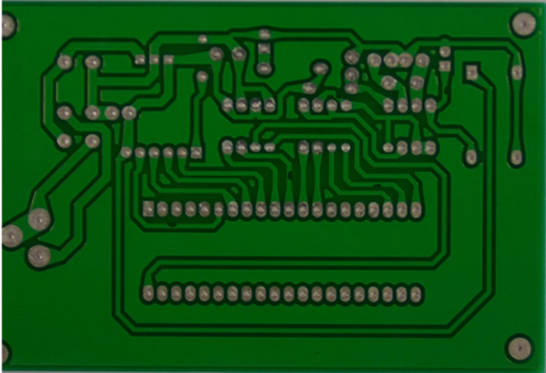 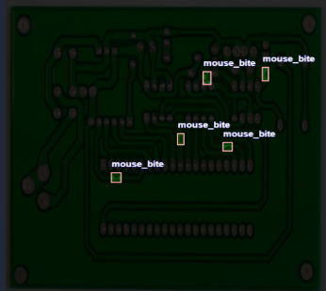 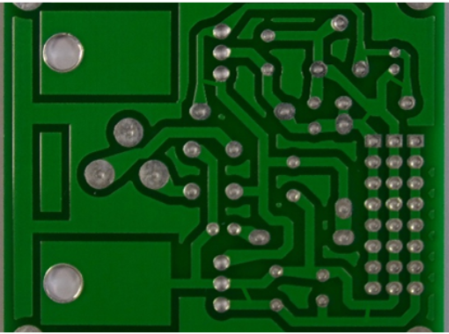 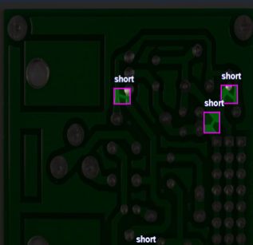

*FIG 1: Unseen Test Set Predictions. Model A inference on the held-out test set, correctly resolving various defects from datasets of test section*

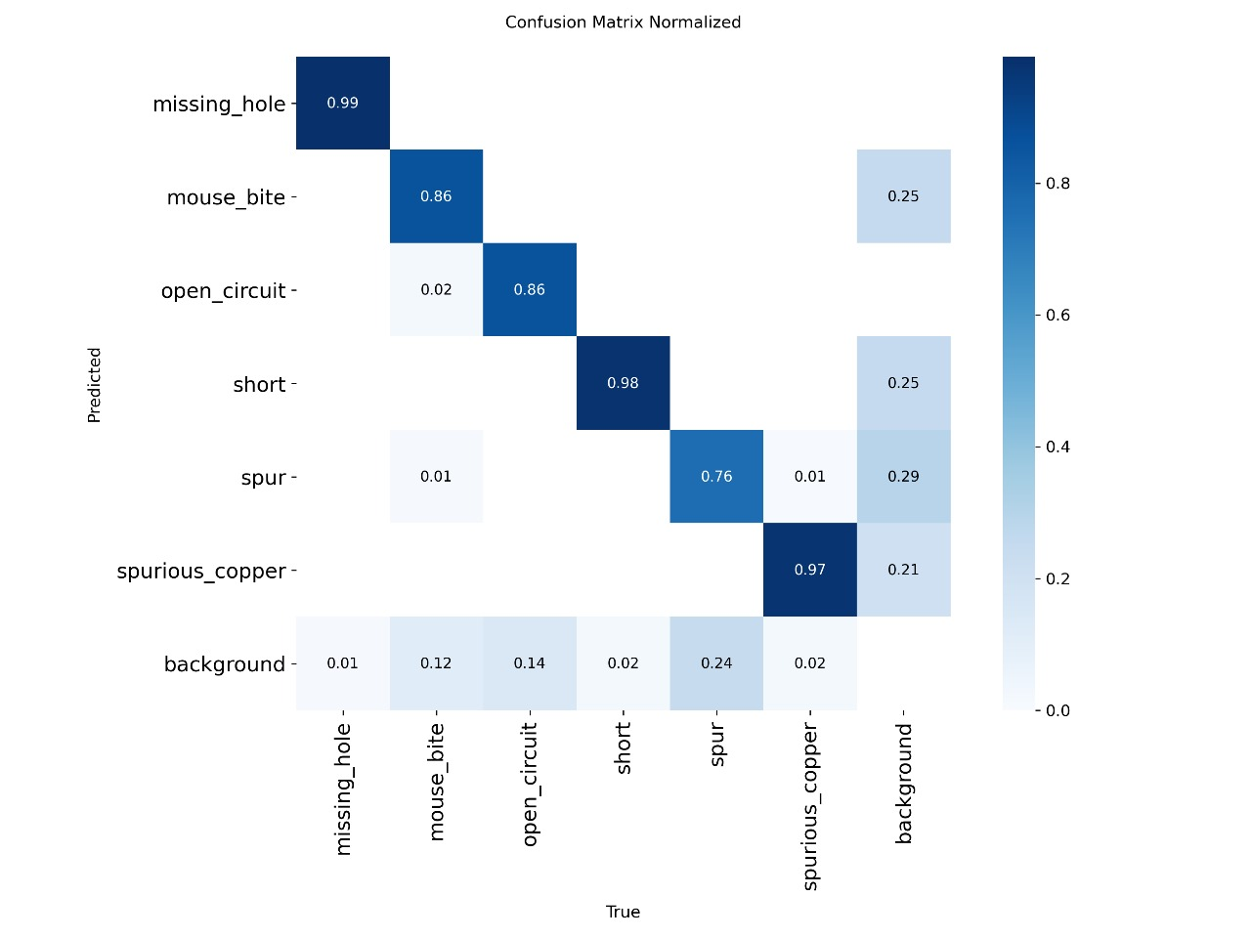

*FIG. 2: Normalized Confusion Matrices. (a) Model A reveals that 'Spur' defects are occasionally misclassified as background due to their small pixel footprint (29% error rate).*

2.MODEL B:

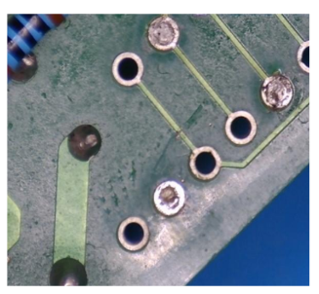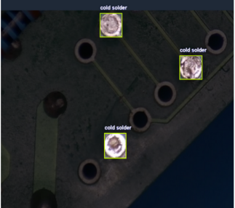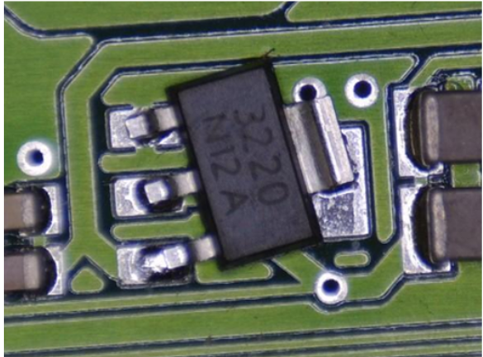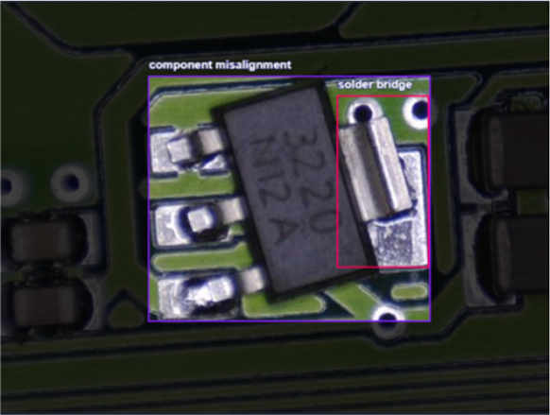

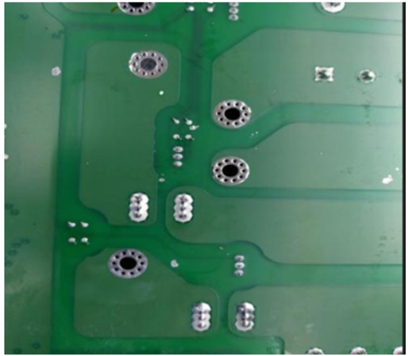 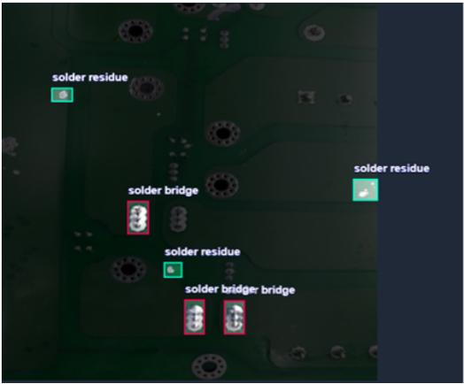 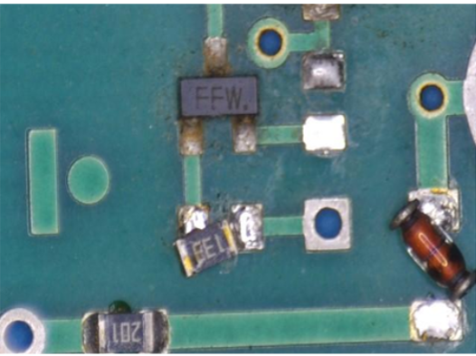 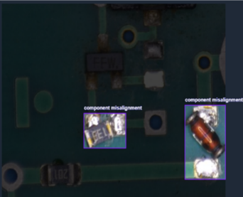

*FIG. 3: Unseen Test Set Predictions. Model B inference on the held-out test set, successfully identifying multi- defects of various pcb boards of test section .*

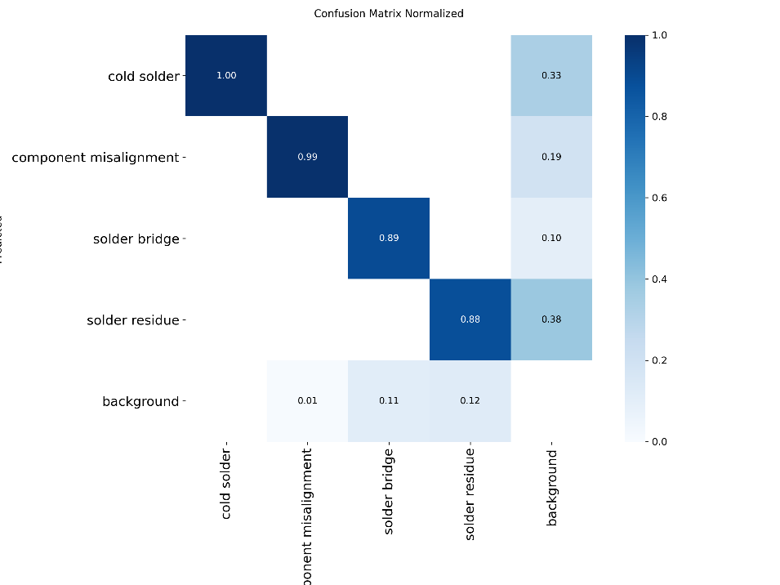

*FIG 4: Normalized Confusion Matrix for Model B. The matrix reveals that 'Solder Residue' is occasionally misclassified as 'Background' (12%), highlighting the challenge of distinguishing faint flux marks from the board substrate.*

3. CAMERA DETECTED IMAGES:

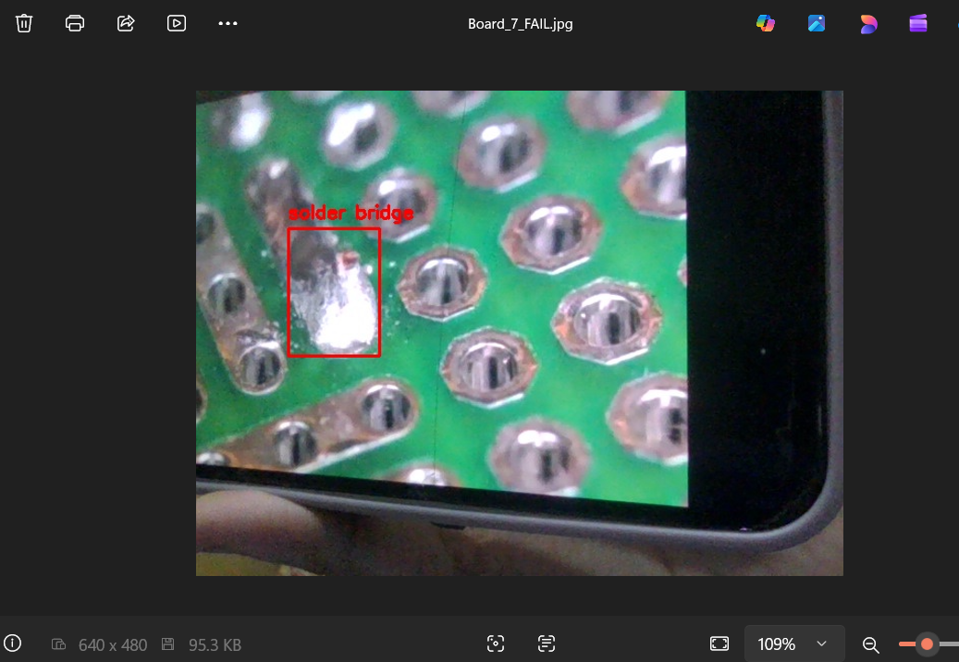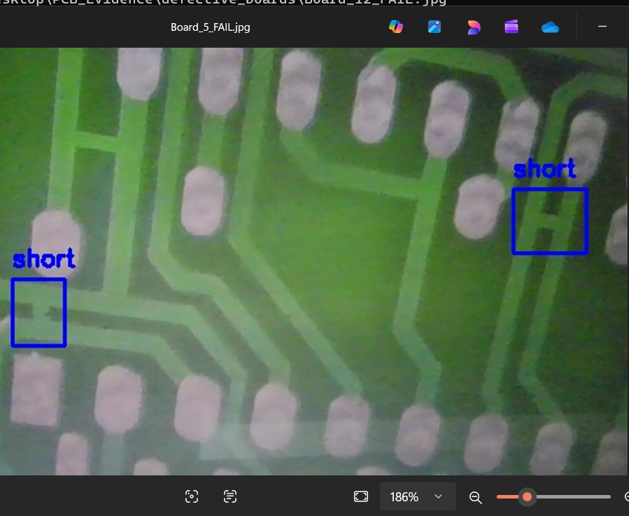 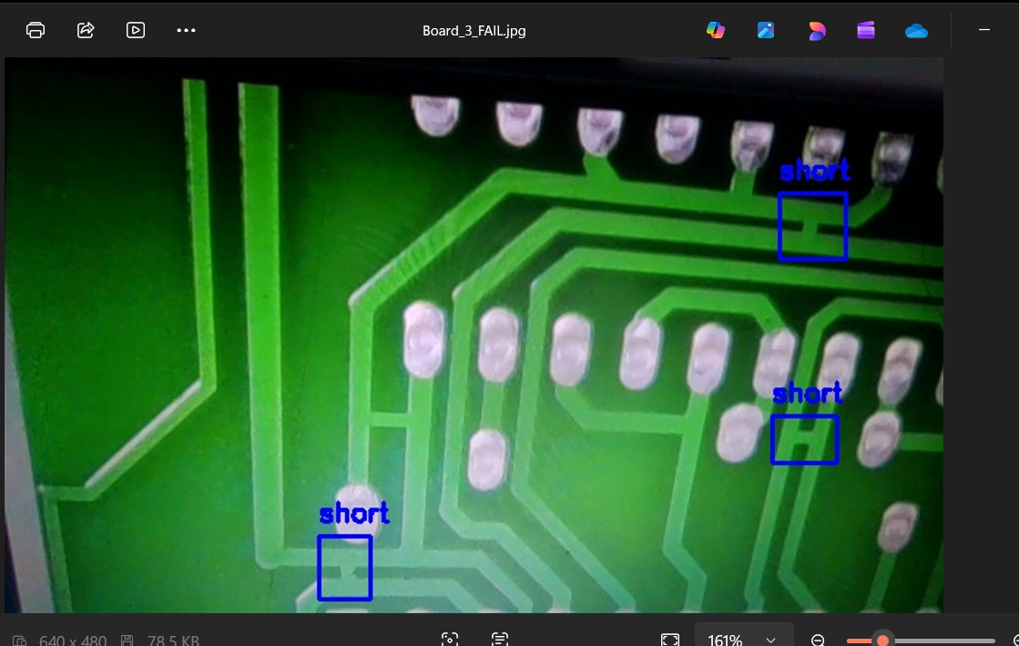

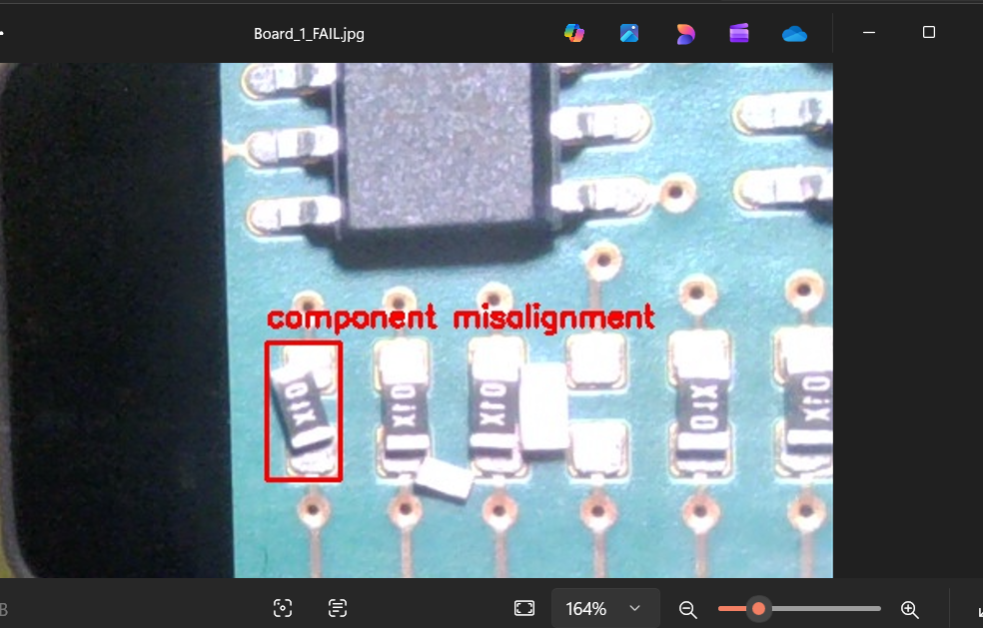 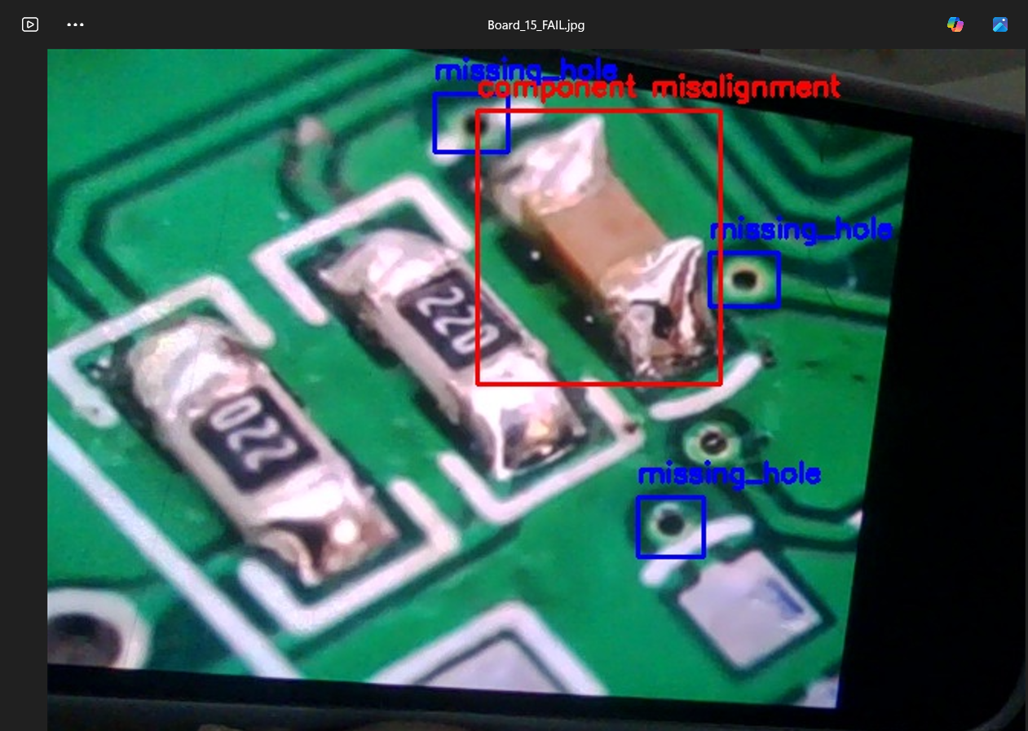

*FIG. 5: Real-World Validation****.****Live inference results demonstrating the model's robustness in detecting defects (e.g., 'Short', 'Solder Bridge') on physical PCBs under varying lighting conditions.*